ECE/BME 591 Team Weekly Progress and Goals Spring 2026
Team: ECE 8 / Cow Bois Date: 01/22/2026
Members present:
____ Gantzen Miller ____ Christian Evans ____ Kennedy Jones
____ Pete Ozegovic ____ Ben Rogers ____ Abdullah Ali

Progress Updates
Member | Last week’s goal(s)
Gantzen Miller | - Make an order for parts to finish sensor construction.  - Design and print sensors and finish construction of them.
Christian Evans | - Research power supply design requirements for SIM7600 board and the design’s sensors.  - Determine voltage levels needed for all components  - Rough sketch of network
Kennedy Jones | - Choose sensors and reviewed related parts
Pete Ozegovic | - Define sensor interface plan (I2C) and develop potential pin map.  - Define desired programming flow and logic for the design.
Ben Rogers | - Develop MQTT data flow plan
Abdullah Ali

Member | Progress for last week’s goal(s)
Gantzen Miller | - Make an order for parts to finish sensor construction – 100%  - Design and print sensors and finish construction of them – 35%
Christian Evans | - Researched SIM7600 board requirements. Still need to consult a professor on the transient requirements of the modem rail – 75%  - Voltage levels: 3.3V for ESP32, 3.8V for modem, and 5V for the sensors – 100%  - Sketch of network included in the Additional Updates and Evidence section – 100%
Kennedy Jones | - Chose sensors and reviewed related parts – 100%
Pete Ozegovic | - Define sensor interface plan (I2C) and develop potential pin maps. – 70%  - Define desired programming flow and logic for the design. – 100%
Ben Rogers | - Developed MQTT data flow plan – 100%
Abdullah Ali

Member | Next week’s goal(s)
Gantzen Miller | - Finish constructing sensors  - Prepare to test both constructed sensors’ accuracy with ESP32 (Op Amps Required)  - Begin planning PCB design and box concept
Christian Evans | - Determine current requirements for sensor rail  - Have a rough LTSpice schematic setup with SMPS and LDO’s (likely not functional yet)  - Speak with faculty about the modem rail and its unique transient requirements.
Kennedy Jones | - Research each specific sensors voltage and communications requirements  - Begin testing sensors for accuracy in Mesonet testing lab
Pete Ozegovic | - Setup ESP32 dev environment + repo structure. (Calibrate ESP32 ADC)  - Bring up I2C bus.  - Implement + validate basic drivers for sensors.  - Decide MQTT topic naming + broker connection method.
Ben Rogers | - Continue research on T-SIM7600 cell modem  - Begin configuration of microcontroller and cell modem for data transmission and reception purposes  - Identify SIM card suitable for needs of this project  - Finalize configuration for testing of cell modem with Raspberry Pi
Abdullah Ali

Schedule Update:
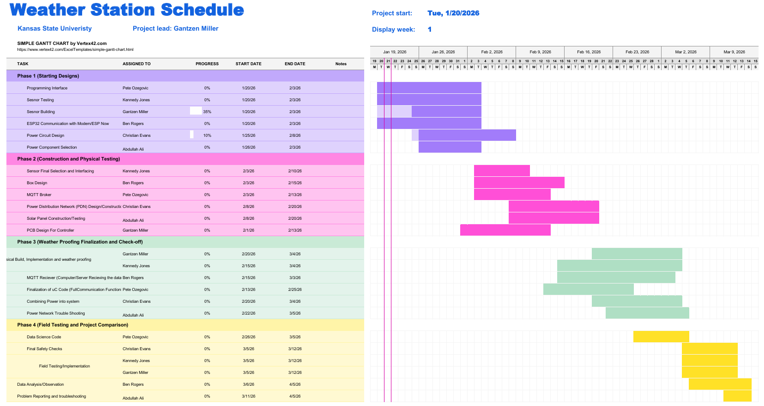

Budget Update:
Section: | Amount Left | Parts Included:
Sensors | $76.55 | Measuring Devices,  Parts
Board/Modem | $113.18 | PCB Construction,  PDN,  Battery/Charge Control,  Modem
Packaging/Mechanical | $184.72 | PETG,  Weather Proofing,  Station Mounting,  etc.
Additional Funds | $200 | Problems,  Data Plan,  Manufacturing Costs
Total | $374.45 - $574.45

Additional Updates and Evidence:
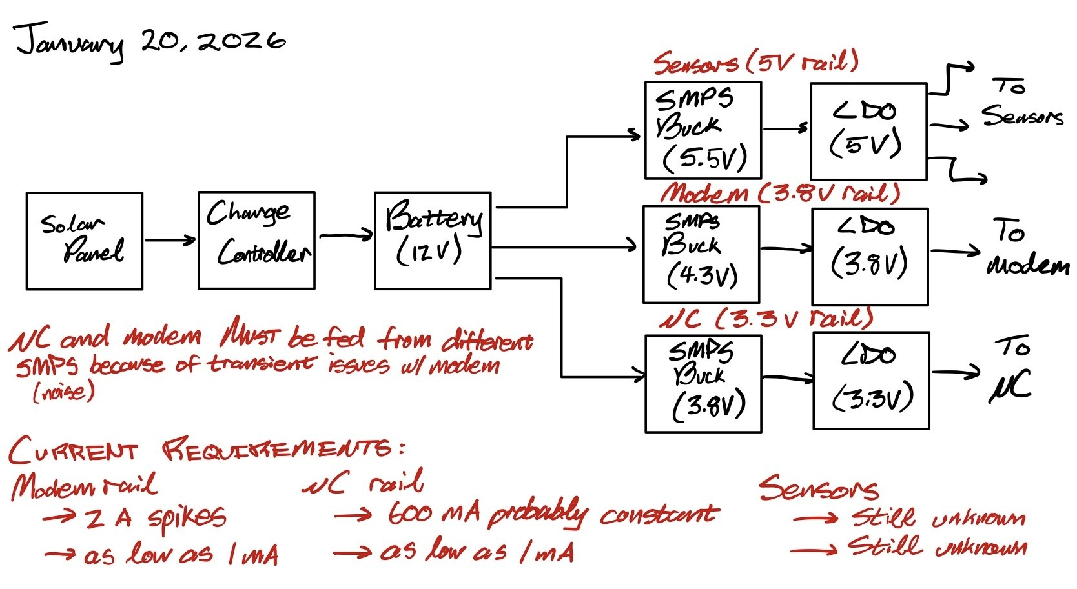
Figure 1 – Rough sketch of PDN on paper. Included are current requirements for the modem and the microcontroller rails.

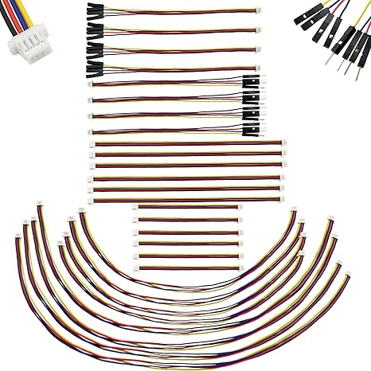
Figure 2 – Stemma QT Connectors for testing and implementation (part of recent order request)

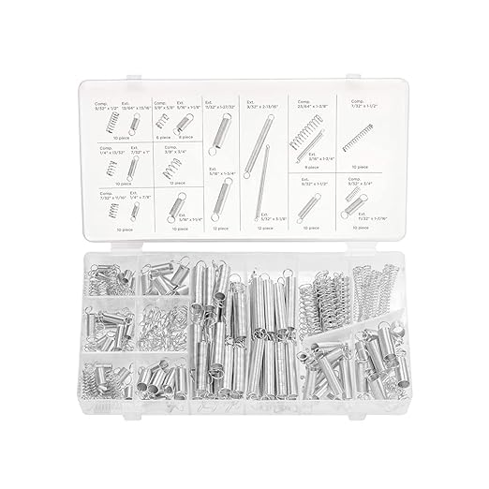
Figure 3 – Spring Assortment Box for rain gauge sensor (part of recent order request)

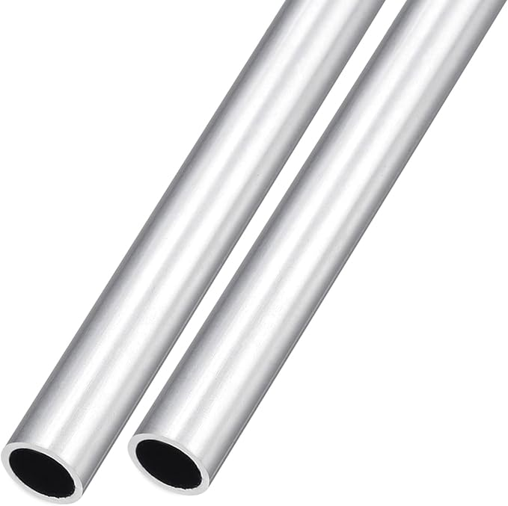
Figure 4 – Aluminum Tube for wind gauge sensor (part of recent order request)

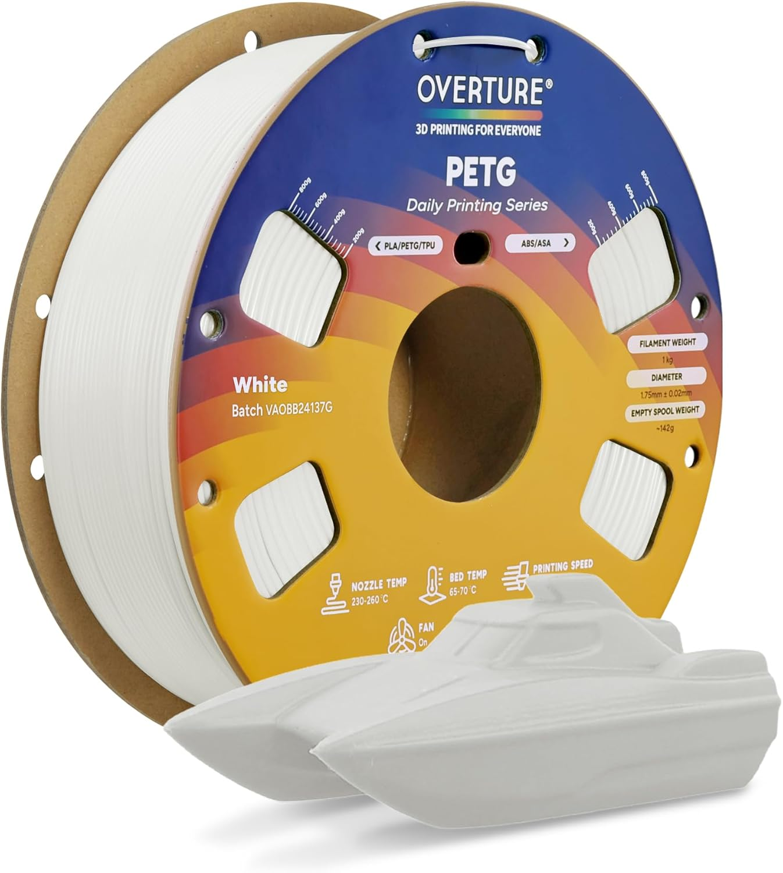
Figure 5 – PETG Spool for box design and sensors (part of recent order request)

